***Mathematical modelling of future trends in TB epidemiology in China and the potential impact of TB vaccines in this population***

***Authors:*** Rebecca C Harris, Tom Sumner, Gwen Knight, Richard G White

***Funding:*** Aeras

**EXECUTIVE SUMMARY**

*Introduction:*

With an estimated 1.4 million prevalent cases in 2012, China is estimated to have the second largest number of tuberculosis (TB) cases globally. There is much uncertainty around the impact of China’s demographic transition on the burden of tuberculosis disease, as the increasing elderly population combined with a decline in the annual risk of TB infection may alter the trajectory of China’s TB epidemic. Novel TB vaccines are anticipated to be an important tool for achieving the 2050 WHO target of elimination of TB as a public health problem. Therefore an understanding of the potential impact on the overall TB epidemiology in China due to protecting older adults and elderly through vaccination is useful for planning development and implementation strategies for novel vaccines.

*Aim:*

To understand the relative contribution of the elderly population to Mtb transmission in China, and estimate the impact of new TB vaccines targeted to older adults and the elderly in China, in several scenarios of vaccination coverage and vaccine characteristics (mode of action, efficacy and duration of protection).

*Methods:*

An age structured transmission model, incorporating social mixing patterns, was used to estimate the age-specific TB burden between 2000 and 2050 in a baseline scenario. The model was calibrated to data and estimates of: overall and age-stratified estimated population size for 2010 and 2050, pulmonary TB prevalence rates in 2000 and 2010, and TB incidence rate and TB mortality rate estimates for 2010. Pre-infection and post-infection vaccine profiles (efficacious only when delivered uninfected individuals, or when delivered to either infected or uninfected individuals, respectively) were explored, varying vaccine efficacy (40%, 60% and 80%) and vaccine coverage (30% and 70%). Vaccine was assumed to be available from 2025, and was delivered as a rolling campaign to 55 year olds, with a 3-year catch up campaign in older adults (55-64 years). All vaccines were assumed to provide 20 years duration of protection with 5% waning per year, therefore providing continued protection for many individual into the elderly period (≥65 years). The model outcomes were: population attributable fractions (PAFs) by age at baseline, reduction in TB disease incidence rate and TB mortality rate in 2050 in the intervention scenarios versus baseline, and number needed to vaccinate (NNV) per TB disease case or TB death averted during the period 2025-2050.

*Results:*

Model results suggest the PAF of the elderly to total population *Mtb* transmission is anticipated to increase from 37% in 1970 to 66% in 2020 in the baseline scenario, and that vaccination could reduce the population-level tuberculosis incidence rate by 1.2%-21.5% by 2050 and tuberculosis mortality rate by 1.2%-22.3% by 2050, cumulatively averting 160,623- 2,978,349 cases and 5,800-112,057 deaths between 2025-2050. The number needed to vaccinate per TB disease case averted over 2025-2050 was 130-1,167 and per death averted was 3,430-32,409. Post-infection vaccine profiles provided consistently greater impact than pre-infection vaccines profiles. The most effective post-exposure elderly vaccine profile and strategy reduced population-level TB incidence to 37.9/100,000population/year in 2050.

*Conclusion:*

Our results suggest that the contribution of the elderly to *Mtb* transmission in China is likely to increase in the coming decades, and that pre-infection vaccines would have limited impact on TB rates, whereas post-infection vaccines, if developed, have the potential to reduce TB incidence and mortality rates by almost a quarter by 2050. However, even the most effective profile and strategy explored would need to be part of a package of other interventions to be able to reach the WHO 2050 goal of TB elimination as a public health problem.

**INTRODUCTION**

With an annual budget of $359 million per year, second only to Russia, China’s National Tuberculosis Programme (NTP) has demonstrated significant progress against the country’s Tuberculosis disease (TB) epidemic in the past two decades. From 1990 to 2010 smear positive tuberculosis incidence fell from 170 to 59 cases per 100,000 population.1 Case detection rates have increased from 32% to 89%, treatment success has been maintained at 93-95%, and the proportion treated in the public health system with DOTS has increased from 15% to 66%.1 Despite such progress, China has the second largest number of incident TB cases globally, estimating 1 million cases (880,000-1,100,000) in 2012.2 Further scale-up of existing interventions may be possible, but given the significant progress in this regard in the last two decades, innovative control measures such as novel TB vaccines are likely to be required, in addition to existing measures, to reach the WHO 2050 targets.

China’s population is undergoing a significant demographic shift, with an increasing proportion of the population classed as elderly, defined as adults aged 65 years and above. The proportion of China’s population constituted by the elderly, will almost triple between 2010 and 2050, with an increase from 8.3% to almost a quarter (23.9%) of the total population.3 Although India is projected to overtake China in terms of overall population size in 2028, China will remain having the greatest number of elderly people globally, with a projected 90.4 million persons aged 80 or above by 2050.3 There is much uncertainty around the impact this may have on the future TB epidemic, as reactivation disease in the elderly due to immunosenescence may alter the trajectory of China’s TB epidemic. Mathematical modelling to explore the impact of this demographic shift on TB disease burden and *Mycobacterium tuberculosis* (*Mtb*) transmission is a useful tool to estimate the magnitude of this unknown. A model based on realistic predictions of future demographics and epidemiology is a useful tool for effective decision making in TB control with existing measures and planning for implementation of pipeline interventions such as new vaccines.

Mathematical models to-date have focussed on global- or regional-level modelling of new vaccines. Recent models by Abu-Raddad *et al.* and Dye *et al.* modelled the impact of theoretical infant and adult vaccines, amongst other interventions, in a South-East Asian setting.4,5 Whereas Knight *et al.* considered a more ‘global’ vaccine impact across 93 countries.6 Abu-Raddad included supplementary analyses, estimating that 11.5-59 million cases could be averted in the WHO Western Pacific Region (to which China belongs) between 2015-2050, depending on vaccine profile.4 However, no model has considered the potential impact of new TB vaccines capturing the demographic changes that are underway and anticipated in China, and no models have considered the public health impact of vaccination specifically of the elderly against tuberculosis. The elderly age group could prove an undervalued target for tuberculosis control, particularly in ageing populations. Here we explore the public impact of vaccinating the elderly, to inform appropriate and efficient design of TB vaccine clinical development plans both by Chinese vaccine developers and international developers aiming to tackle the significant burden of disease in China.

**AIMS AND OBJECTIVES**

Aim: Understand the relative contribution of the elderly population to *Mtb* transmission in China, and estimate the impact of a new TB vaccines targeted to the elderly in China, considering several scenarios of vaccination coverage and vaccine characteristics such as vaccine mode of action, efficacy and duration of protection.

Objectives:

1. To create baseline model scenarios estimating relative potential contribution of the elderly to the on-going transmission of *Mtb* in China
2. Explore potential impact of novel TB vaccines delivered to elderly populations, considering both pre- and post-infection vaccines and varying efficacy, coverage and duration of protection.

**MATERIALS AND METHODS**

**Data**

Demographic data, including age-stratified population size estimates for 2010 and 2050, were taken from the UN population division 2012 revision.3 High and low fertility estimates in the UN population division provided the upper and lower bound of population size for the child (0-14 years) and adult (15-54 years) age groups in 2050. Bounds for older adult (55-64 years) and elderly (≥65 years) groups were assumed to be +/- 10% of the point estimate. Age-stratified prevalence of bacteriologically-positive pulmonary TB disease was obtained from national prevalence surveys conducted in 2000 and 2010, reported in Wang *et al.* (2014).1 Mortality rates by age were collated from Disease Surveillance Point data, which is considered nationally representative. 7

TB incidence stratified by age is not currently reported by the WHO, only country-level incidence and age-wise notifications are available. Therefore, TB incidence for 2010, stratified by age, was estimated by uniformly applying the WHO-reported China case detection rate (CDR) to the age-wise notifications of all TB (including smear positive, smear negative, and extra-pulmonary TB) in China. This assumption was demonstrated to be broadly valid by comparison to the sum of the estimates to WHO’s reported all-ages incidence for China. Population size estimates for 2010 were applied to TB incidence number estimates to calculate age-stratified TB incidence rates.

**Model and baseline (no-intervention) scenario**

We used an age structured transmission model to estimate the TB burden in a baseline scenario and a range of alternative vaccination scenarios (Fig. 1). A full description of the model is provided in appendix A. The model was programmed in R (ref).

This model was calibrated to overall and age-stratified China-specific data for all of the following: the estimated population size for 2010 and 20508, pulmonary TB prevalence rates in 2000 and 2010, TB mortality rate and TB incidence rate estimates for 2010. In this preliminary analysis, the model was fitted manually to the calibration data. A prioritisation hierarchy for fitting was employed, by first fitting the demographic characteristics of the China population, followed by disease characteristics of the China population, in order of data quality.

Repeated cross-sectional TB disease prevalence data from prospective national screening surveys conducted by stratified random sampling from the 31 provinces are the most robust,[ref Wang] therefore prioritisation was given to fitting to these data.

Mortality calibration targets are also relatively robust as they are based on cause of death determined by medical report and verbal autopsy collected from Disease Surveillance Points, a representative 1% sample of China’s population from 145 reporting sites selected by stratified cluster random sampling.[ref zheng/hui] However, this method of determination of cause of death is less reliable than prevalence determined by smear microscopy and culture, therefore mortality was secondary to prevalence calibration.

Due to the uncertainty introduced by using the case detection ratio (CDR) to calculate incidence calibration targets (see section xxx for details), the incidence calibration targets are the least robust, and therefore were lowest priority when model fitting. In addition, data from some countries have indicated that the CDR may be lower in elderly populations due to diagnostic difficulties and reduced access to care,[japan paper+identify others] thus the assumption of uniform CDR to estimate the age-wise incidence calibration targets is likely to have underestimated the true elderly incidence. Therefore, to fit the model to the prioritised calibration factors, the CDR was varied independently for the elderly and non-elderly, limiting the elderly CDR fitting parameter to equal to or lower than the non-elderly fitting parameter. Given this assumption, when fitting the model to incidence it was ensured that the model output for elderly incidence was higher than the calibration elderly incidence, but the model was not specifically fitted to the elderly incidence data.

To fit the model, selected natural history parameters were varied by age. Proportion of (re-) infected individuals developing active TB (*p*) and proportion of new active cases directly becoming infectious (*f*) included parameters for each of children (0-14 years), adolescents, adults and older adults (15-64 years) and the elderly (65 years and above), with the elderly ranges for parameter sampling based upon combined adult and HIV-positive adult ranges to account for the impact of immunosenescence (Table C1). Risk of reactivation (*v*), risk of relapse (*r*) and the CDR scaling factor (*CDRscale*) were independently varied by elderly (≥65 years) and non-elderly (<65years), with the elderly upper bound based upon the lower bound of the HIV-positives range for the given parameter. Population social mixing between different age strata were based on data on social mixing patterns from a study in Southern China.[Read et al 2014] Estimates of projected TB incidence rates and mortality by age between 2010 and 2050, in addition to cumulative cases and deaths in 2050, were calculated assuming BCG coverage at current levels. To reflect significant achievements in TB control scale-up in China in the last decade,1 in this preliminary modelling a single baseline scenario assuming no change in case detection and treatment success after 2012 was taken.

**Intervention scenarios**

Vaccine introduction was implemented over 2025-2050. Vaccine profiles differed by mechanism of action, and vaccine efficacy and different coverage scenarios were explored.

We investigated six vaccine profiles including two mechanisms of action, vaccine efficacies of 40%, 60% or 80%, each with a duration of protection of 20 years and 5% waning per year.

*Mechanism of action*

The pre-infection vaccine was assumed to prevent development of active disease only when delivered to never-infected individuals (S), whereas the post-infection vaccine is assumed to prevent development of active disease when given to populations never-infected (S), latently infected (L), or recovered from active disease (R).

*Efficacy*

Vaccine efficacy was modelled as 40%, 60% and 80% protective against development of TB disease. Vaccination was modelled as ‘take’, meaning that the proportion of the population immunised (therefore entering the vaccinated class) was a combined function of those receiving vaccine (coverage) and vaccine efficacy.

*Duration*

An initial assumption will be made of waning of protection by 5% per year. As protection is exact, those individuals experiencing waning leave the vaccinated category and return to the equivalent unvaccinated state. All vaccine scenarios assume 20 years duration of protection, therefore remaining individuals leave the vaccinated category at age 75 years.

*Age targeting and coverage scenarios*

Vaccination involved steady-state continuous vaccination of adults aged 55 years old from 2025 until 2050. Coverage scenarios of 30% and 70% of the target population and instant scale up were assumed. A ‘catch up’ campaign of older adults (56-64 year olds) was included in 2025-2027. It was assumed that the catch-up campaign would achieve the same final percentages of coverage (i.e. 30% and 70%), but scale-up would occur uniformly over a 3-year campaign (e.g. 30% final coverage assumes 10% per year for 3 years). Adults aged 65 years and above were assumed not receive the vaccine due to safety concerns and immune senescence in this age group.

**Outcomes**

In the baseline scenario, the proportion of new versus reactivation cases by age group was calculated.

The population attributable fraction (PAF) for *Mtb* transmission by each age was calculated in the baseline scenario using methods described previously in Orroth et al. The model was first run allowing transmission from all infected populations as a baseline. It was then re-run four times, blocking transmission from infected individuals in one age stratum per run by reducing the infectious proportion to zero for that age group. The difference between the total number of new infections in the year in which transmission was blocked in each of these runs compared to the baseline provided the PAF as a measure of the contribution that age group to transmission in the population as a whole.

The impact of the potential TB vaccine profiles was measured using:

* Percentage reduction in TB incidence and TB mortality rates in 2050 compared to the baseline scenario,
* Cumulative cases and deaths averted over 2025-2050 compared to baseline.
* The number needed to vaccinate (NNV) per TB case and per TB death averted.

The number needed to vaccinate per TB case or death averted was calculated by dividing the total number of vaccines delivered between 2025-2050 (D) by the difference between the number of cases or deaths in the baseline scenario (B) versus the vaccine scenario (v) in 2050.

NNV = D/(B-V)

The NNV was calculated for the outcome of interest in all ages, for the older adults alone, and for the elderly alone.

**Future methods**

The results presented in this report are preliminary outcomes of the model. The following work has been identified for the next phase of model development (outside current contract with Aeras).

* Add uncertainty to model baseline scenarios and impact estimates
  + Model calibration at this stage has been conducted by manual fitting to the data. In the next phase of development, the model will be fitted using Sobol sequence sampling and Approximate Bayesian Computation approach.
* Refine calibration targets
  + Due to the assumption that CDR is different in the elderly, fitting will be to notification data as opposed to an incidence calculated assuming a uniform CDR. The model output will remain as incidence, as this is the outcome of interest for the vaccination scenarios. Although no data were available at the time of this report, it is hoped that in subsequent development of this model that it will be possible to calibrate the model to the prevalence of latent infection.
* Vary vaccine waning scenarios
  + As the likely extent of vaccine waning is currently unknown, we will explore different vaccine waning scenarios in future model runs.
* Estimate relative benefit of vaccinating elderly versus vaccinating adults
  + A comparison of the impact of elderly vaccination versus other potential vaccination strategies would be valuable in assessing the most effective method of reducing tuberculosis incidence and mortality. Therefore, we will assess the impact of the same vaccine profiles delivered to adults, and if the two vaccination programmes were run in tandem.

***RESULTS***

***Baseline model fit***

Modelled demographics calibrate well to the UN Population Division age-stratified population size estimates for 2010 and 2050 (Figure XX).[ref UNDP 2012] A good model fit to the prevalence of bacteriologically-positive tuberculosis in 2000 and 2010 was achieved, both overall and by age stratum (Figure XX).

As has been noted by others (Targets modelling report), estimated tuberculosis mortality rates in China are very low given the disease prevalence. Due to this apparent disparity, the modelled mortality rates in adults and the elderly are 2-3 times higher than indicated by the data (Figure XX);[ref Zhang *et al.* 2014] however, overall and by age the mortality outputs are considered a reasonable preliminary fit to the data. Due to the assumption of uniform CDR when calculating the incidence calibration targets, the model output incidence rates were a good fit overall and in the non-elderly age groups, but was too high relative to the calibration target in the elderly (Figure XXX).

***Baseline model output***

In the baseline scenario, the overall TB disease incidence rate is projected to decline from 68.8/100,000population/year in 2025 to 48.3/100,000population/year in 2050 (Figure xxx, top left panel). Baseline mortality fell from 3.77/100,000population/year in 2025 to 2.09/100,000population/year in 2050 (Fig xxx) .

Prevalence of *Mtb* infection data were not available for calibration in the preliminary model, however this baseline output is presented in Figure XXX. It shows that prevalence of infection increased with age, ranging from 6% in children to 55% in older adults and elderly (≥55 years) in 2000. The overall modelled prevalence of infection declined from 28% in 2000 to 12% in 2050, and all age groups experienced large declines in infection prevalence during this period (6% to 0.2% in children, 29% to 4% in adults, 53% to 17% in older adults, and 57% to 32% in the elderly). The decline in prevalence of infection appeared to begin later in the elderly age group, which may be a reflection of the age mixing assumptions of the model, because xxxx

The modelled baseline plots of the proportion of new incident TB disease cases constituted by new infections versus reactivation disease are presented (Figure XXX). The majority of incident TB disease cases in the population below 55 years of age have been consistently caused by new infections. Historically, this was also the case in the population above this age; however, the model suggests that a switch from new infections towards reactivation disease occurred in the elderly around the year 2000, and in older adults and the overall population in the last few years. The model suggests that reactivation disease could constitute more than 80% of the elderly incident cases by 2050. It is thought that this switch may be caused by scale up of existing control measures over the last few decades, as control efforts may have decreased TB transmission enough to shift the epidemic from an ‘ongoing transmission-driven’ (new infections) to a ‘reactivation-driven’ epidemic consisting mostly of reactivation of old infections, indicating a potentially waning epidemic.

PAFs estimated from the model suggest that in 1970 20-64 year olds and ≥65 year olds were responsible for 54% and 37% of new *Mtb* infections, respectively. By 2020 the PAFs for 20-64 year olds and ≥65 year olds had changed to 33% and 66%, respectively (Table 1). Therefore, the model suggests that proportionally new infections will be increasingly transmitted from the elderly population; which, given the modelled increase in reactivation disease in the elderly, supports the notion of a shift from an ongoing-transmission to a reactivation epidemic.

***Epidemiological Impact of TB vaccines***

*Vaccine Impact on TB Incidence and Mortality*

The vaccine profiles explored reduced the incidence rate from a baseline of 48.3/100,000population/year to ranging from 37.9-47.7/100,000population/year in 2050, equivalent to 161,000 - 2,978,349 TB disease cases averted over the 2025-2050 period (Table xxx). The same vaccine profiles reduced mortality from a baseline of 2.09/100,000population/year to 1.63-2.07/100,000population/year, avoiding 6,000 - 112,057 deaths from 2025-2050. Both incidence and mortality were reduced by 1.2% to 22%, depending on vaccine profile explored. In each scenario, the lowest impact was delivered by a pre-exposure vaccine with 40% VE and 30% coverage, and the highest impact achieved by a post-exposure vaccine with 80% VE and 70% coverage.

Considering the impact in older adults (55-64 year olds) demonstrates more clearly the direct vaccine effects (in addition to indirect effects). The vaccines explored reduced TB disease incidence rates by 4.1%-48.6% and TB mortality rates by 3.5%-43.1% in older adults (Table xxx). Indicating a large direct impact of the vaccines in this age group. The reduction in TB incidence and mortality rates in children (0-14 years) and adults (15-54 years) are relatively similar to one another (Figures xx-xx), demonstrating similar indirect effects of the vaccine on *Mtb* transmission to these other age groups due to similar contact patterns and the majority of cases in both groups being due to new infections (figure xxx). In many of the scenarios, children experience a marginally greater indirect effect, likely explained by the high levels of contact between the vaccinated population and the youngest age groups (0-19years) and the very high proportion of cases in children (0-14 years) attributable to new transmission (>90%) (Figure xxx). Vaccine impact is marginally lower in the elderly than the other age groups. The protection observed is likely mostly caused by direct vaccine efficacy in those remaining immunised, since given the majority of cases are reactivation disease in the elderly (see figure xxx) there will be limited indirect effects of the vaccination programme in this age group.

To provide a comparison between equivalent profiles, the population-level impact that can be expected with 70% coverage of an 80% effective pre-infection or post-infection vaccine is 5.2% reduction in incidence rate and 5.1% in mortality rate compared to baseline in 2050 for pre-infection vaccines, and a 21.5% reduction in incidence rate and 22.3% in mortality rate in the equivalent post-exposure vaccine. The equivalent figures specifically for the older adults directly targeted by the vaccination programme were 18% and 16% for the pre-exposure vaccine, and 49% and 43% for the post-exposure vaccine (Table xxx). Prevalence of latent infection was relatively high in the older adult (55-64 years) age group to whom the vaccine programme was targeted (40.7% in 2025, Figure 5), therefore pre-infection vaccine impact is limited by the proportion of the population already/previously infected and therefore unable to benefit from a pre-infection vaccine.

*Number Needed to Vaccinate*

The number needed to vaccinate (NNV) per case averted ranges from 579-1167 for pre-infection vaccines and 130-261 for the post-infection profiles (Table XXX). Assuming that the unit cost of vaccine and delivery is the same for both vaccine types, the cost per case averted could be 4-5 times higher for a pre-infection vaccine than the equivalent post-exposure profile.

Depending on vaccine type, the NNV per case avoided is 31-40% lower when considering overall cases avoided compared to considering those avoided in the elderly population alone, demonstrating that the vaccine has an indirect effect on the unvaccinated population by impacting transmission.

The number needed to vaccinate per death avoided is, as expected, much higher than the NNV per case avoided. The NNV per death averted for a pre-exposure vaccine ranges from 16083-32409, and for a post-exposure vaccine ranges from 3430-6910.

For NNV for both cases and deaths averted is marginally higher with a coverage rate of 70% as opposed to 30%. As the incidence rates are consistently lower in the scenario with higher coverage, this outcome was somewhat unexpected. The NNV is dependent upon the timeframe of the study, and it is thought that this slightly unusual result may be a result of the extended duration over which the NNV is evaluated. It is possible that the NNV is indeed lower with 70% coverage to begin with, but with the greater reduction in incidence that this coverage would provide, the NNV becomes higher as incidence rates drop. This will be explored further during the second phase of model development.

***DISCUSSION***

The preliminary results of the research presented here suggest that an ‘elderly’ vaccine delivered to 55 year olds with 5%/year waning and 20 years maximum protection has the potential to provide an important contribution to TB control in China. Given the anticipated population ageing, the proportion of total TB cases contributed by the elderly population is expected to rise. Recent success in programmes to reduce the force of infection through improved CDR and treatment has had a significant impact on prevalence of TB in China, yet TB incidence remains high thanks to the high rates of reactivation disease from latent infection. This predominance of reactivation disease by 2050 is attributed to the decreasing force of infection due to these programmes coupled with the increasing size of the elderly population who have experienced historical high forces of infection and are experiencing reactivation due to immune senescence. Therefore, elderly vaccines to help counteract the increasing importance of this population in the TB epidemiological picture could be an effective addition to existing control programmes.

Post-infection vaccines, particularly the higher vaccine efficacies and coverage, were demonstrated to have the potential to reduce TB incidence and mortality rates by up to 21.5% and 22.3%, respectively. This reduction is through both direct vaccine effects on the vaccinated population, and indirect effects on the entire population due to reduction in force of infection by lowering the prevalence of disease in the vaccinated population. The potential impact of pre-infection vaccines in the timeframe studied is considerably lower (up to 5.2% and 5.1% reduction in TB incidence and mortality rates, respectively). The pre-exposure vaccines were assumed to only provide effective protection in the never-infected population (“susceptibles”), therefore since 40.7% of the vaccine-eligible population were latently infected in 2025, in addition to those who have recovered from TB disease, a large proportion of the vaccinated population are not effectively immunised. This explains the low impact of such a vaccine compared to the post-infection vaccine, which is effective in all populations except those with active disease. In estimating the number of vaccines delivered it was assumed that testing for latent infection would not be routinely conducted as part of the vaccination programme; therefore many vaccines would be delivered to latently infected or recovered populations, who would receive no benefit from a pre-infection vaccine, thus explaining the relatively high estimate of the number needed to vaccinate per case or death avoided with a pre-exposure vaccine. If a pre-infection vaccine were to be developed, cost-effectiveness analyses would be required to assess the relative benefit of blanket vaccination versus targeted vaccination by testing for latent infection. However, results presented here indicate that a post-infection vaccine can provide the greatest impact in the vaccinated population and in the population overall, therefore development of a vaccine effective in all of never-infected, latently infected and previously infected populations would be prioritised for use in the elderly population in China.

A post-exposure vaccine with 80% vaccine efficacy and 70% coverage is the highest impact vaccine profile, which reduced the incidence rate to 37.9/100,000population/year in 2050. From a public health perspective this would be an important decrease in the disease burden. However, such a strategy alone is not sufficient to meet the WHO 2050 goals of reducing TB incidence to below one case per million population. Therefore, although a vaccine delivered to the ‘elderly’ could be an important element in the TB control programme for the long-term reduction in TB disease in China, with the vaccine profiles and coverages explored in this model it would need to be part of a package of interventions as opposed to being the sole solution to the TB burden in China.

Comparing these profiles to the TPPs currently in the pipeline, there are candidates that are hoped would provide the vaccine efficacies explored. However, the anticipated duration of protection and vaccine waning are currently unknowns, especially in the elderly given that, to the knowledge of the authors, none of the current vaccines have a TPP for elderly vaccination.

There are several limitations to this study, many of which will be managed in the on-going development of the model. These include the hand fitting to calibration data and some imprecision in the mortality fit, which will be managed through Sobol sequencing and Approximate Bayesian Computation in the next iteration of the model. The uncertainty caused by projecting demographics and TB control measures in to the future will be estimated by including 1000 sets of natural history parameters generated by Sobol sequencing that fit the calibration targets.

As discussed previously, the uniform application of case notification rate for the country to age-wise incidence estimates does not align with the model assumption of age-specific CDRs, therefore the model will be fitted to notification data rather than incidence. The contact matrix employed, based on data from Read *et al*,. was assumed constant throughout the studied period. However, given the changing population structure, it could be expected that contact patterns may change over time. Given that the elderly are representing an increasing proportion of the total population in China, it could be expected that the low levels of contact from this population in the current contact matrix could be replaced with much higher levels of contact in the future. Therefore, in the continued development of this model, we will explore through sensitivity analyses the impact of changing contact matrices over time, including increased contact with the elderly population in the future.

The model assumes homogenous TB epidemiology in China; however, this is known not to be the epidemiological reality. At this stage in vaccine development, the regional level of granularity is not required for decision making and is therefore not required from this model. However, once a vaccine is available, regional tailoring of this model could be valuable to inform evidence-based decision making at the regional level.

The preliminary results of this model developed to explore the impact of different vaccine profiles delivered as an ‘elderly’ strategy indicate that a pre-infection vaccine is likely to have limited direct and indirect impact on incidence and mortality rates, whereas a post-infection vaccine, especially a 60-80% vaccine with high coverage, could have an important impact on TB disease in China. Such a vaccine would not be sufficient to replace existing control programmes, but would be an important addition to the tool kit for TB control given the anticipated future demographic and epidemiological trends in China.

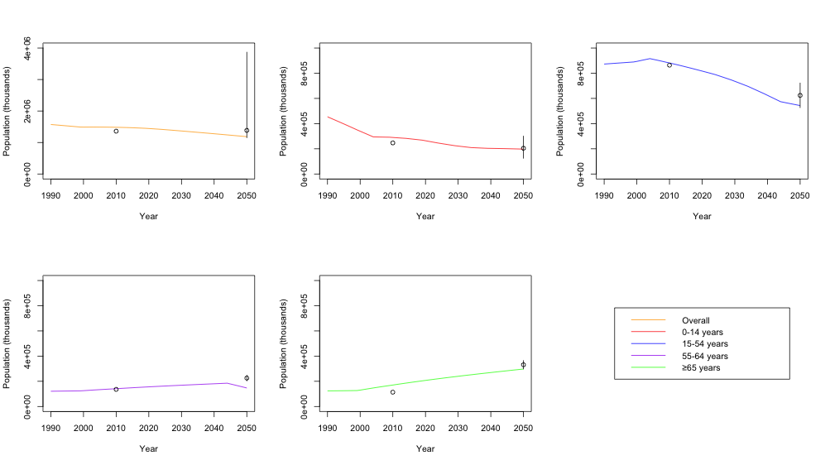

Figure 1: Modelled China population size calibration 2010-2050 for overall population size (top left), and for 0-14 year olds (top centre), 15-54 year olds (top right), 55-64 year olds (bottom left), and ≥65 year olds (bottom centre). Black circles and bars represent empirical calibration data and uncertainty range, coloured lines show model outputs.

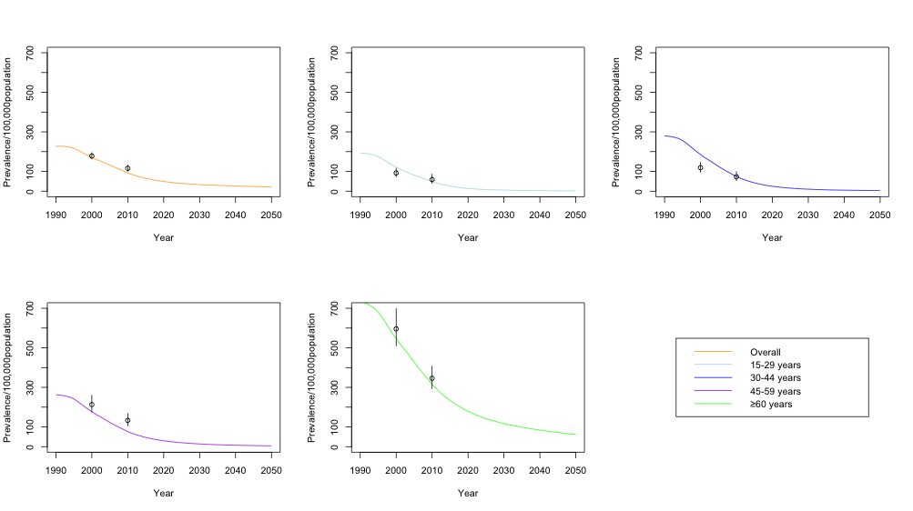

Figure 2: Modelled bacteriologically-positive tuberculosis prevalence rate calibration 2000-2010 for overall population (top left), and for 15-29 year olds (top centre), 30-44 year olds (top right), 45-59 year olds (bottom left), and ≥60 year olds (bottom centre). Black circles and bars represent empirical calibration data, coloured lines show model outputs.

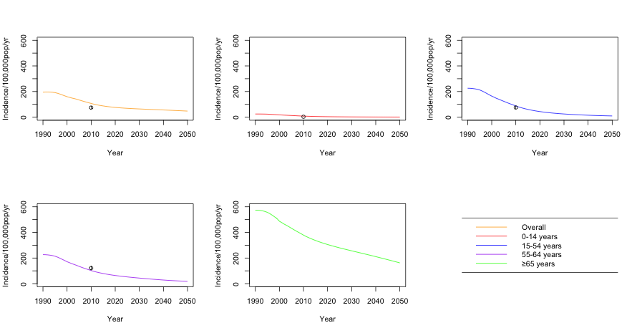

Figure 3: Modelled all-tuberculosis incidence rate calibration for 2010 for overall population (top left), and for 0-14 year olds (top centre), 15-54 year olds (top right), 55-64 year olds (bottom left), and ≥65 year olds (bottom centre). Black circles and bars represent empirical calibration data, coloured lines show model outputs. Calibration target not shown for elderly population as is an underestimation of elderly incidence rates due to assumption of uniform CDR (see section xxx).

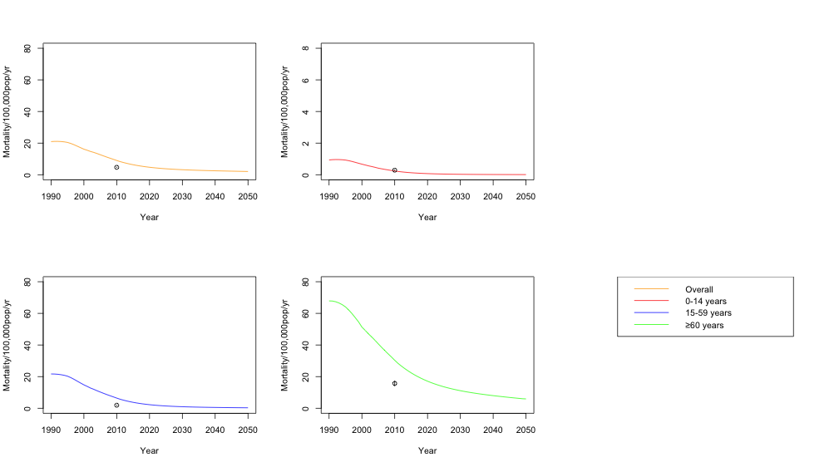

Figure 4: Modelled tuberculosis mortality rate calibration for 2010 for overall population (top left), and for 0-14 year olds (top right), 15-59 year olds (bottom left), and ≥60 year olds (bottom right). Black circles and bars represent empirical calibration data, coloured lines show model output.

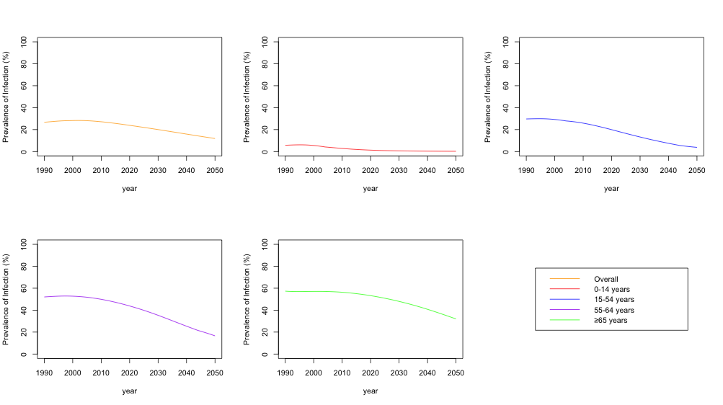

Figure 5: Modelled prevalence of latent tuberculosis infection for overall population (top left), and for 0-14 year olds (top centre), 15-54 year olds (top right), 55-64 year olds (bottom left), and ≥65 year olds (bottom centre).

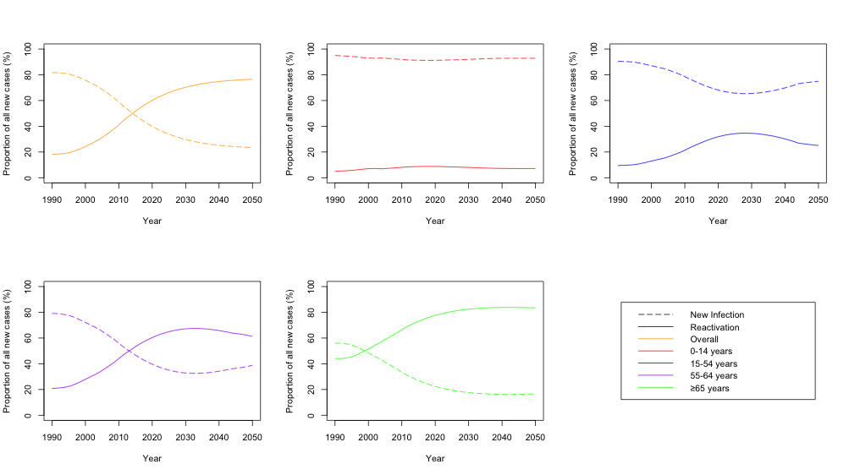

Figure 6: Modelled temporal trend in proportion of all new TB cases due to (re)infection versus reactivation of latent infection in the overall population (top left), and for 0-14 year olds (top centre), 15-54 year olds (top right), 55-64 year olds (bottom left), and ≥65 year olds (bottom centre).

Table 1: Population Attributable Fraction (PAF) of annual number of *Mtb* infections in 1970 and 2020, by age group

|  |  |  |  |  |  |  |
| --- | --- | --- | --- | --- | --- | --- |
| Age group removed | 1970 | | | 2020 | | |
| Baseline | Group Removed | **PAF** | Baseline | Group Removed | **PAF** |
| 0-5yrs | 59750 | 58652 | **1.8** | 3174 | 3161 | **0.4** |
| 6-19yrs | 59750 | 50799 | **15.0** | 3174 | 3086 | **2.8** |
| 20-64yrs | 59750 | 27566 | **53.9** | 3174 | 2138 | **32.6** |
| 65+years | 59750 | 37688 | **36.9** | 3174 | 1078 | **66.0** |

Table 2: Impact on TB incidence rate and mortality rate in 2050 of different pre-infection and post-infection vaccine profiles with 20years duration of protection and 5% waning per year rolled out in 2025 and targeted to 55 year olds, with a 3 year catch up campaign in 56-64 year olds.

|  |  |  |  |  |  |  |  |  |  |  |
| --- | --- | --- | --- | --- | --- | --- | --- | --- | --- | --- |
| **Mode of Action** | **VE** | **Coverage (%)** | **All Ages** | | | | **≥55 years** | | **≥65 years** | |
| **TB incidence rate (per 100,000 pop/year)** | **TB mortality rate (per 100,000 pop/year)** | **% reduction in TB incidence rate \*** | **% reduction in TB mortality rate \*** | **% reduction in TB incidence rate \*** | **% reduction in TB mortality rate \*** | **% reduction in TB incidence rate \*** | **% reduction in TB mortality rate \*** |
| No vaccine | n/a | n/a | 48.30 | 2.09 | n/a | n/a | n/a | n/a | n/a | n/a |
| Pre-infection | 40 | 30 | 47.72 | 2.07 | 1.2 | 1.2 | 1.2 | 1.2 | 1.1 | 1.1 |
| 70 | 47.44 | 2.05 | 1.8 | 1.7 | 2.7 | 2.7 | 2.4 | 2.5 |
| 60 | 30 | 47.16 | 2.04 | 2.4 | 2.3 | 1.8 | 1.7 | 1.6 | 1.6 |
| 70 | 46.98 | 2.04 | 2.7 | 2.7 | 4.0 | 3.9 | 3.5 | 3.6 |
| 80 | 30 | 46.37 | 2.01 | 4.0 | 3.9 | 2.4 | 2.3 | 2.1 | 2.1 |
| 70 | 45.78 | 1.99 | 5.2 | 5.1 | 5.2 | 5.1 | 4.6 | 4.8 |
| Post-infection | 40 | 30 | 45.87 | 1.98 | 5.0 | 5.2 | 5.0 | 5.2 | 4.7 | 5.1 |
| 70 | 44.70 | 1.93 | 7.5 | 7.8 | 11.3 | 11.8 | 10.5 | 11.4 |
| 60 | 30 | 43.56 | 1.88 | 9.8 | 10.2 | 7.4 | 7.7 | 6.9 | 7.5 |
| 70 | 42.81 | 1.84 | 11.4 | 11.8 | 16.5 | 17.2 | 15.4 | 16.7 |
| 80 | 30 | 40.29 | 1.73 | 16.6 | 17.2 | 9.8 | 10.2 | 9.1 | 9.9 |
| 70 | 37.90 | 1.63 | 21.5 | 22.3 | 21.4 | 22.3 | 20.0 | 21.6 |

*Reduction comparing 2050 with vaccination to baseline scenario

Table 3: Impact on TB incidence rate and mortality rate in 2050 of different pre-infection and post-infection vaccine profiles with 20years duration of protection and 5% waning per year rolled out in 2025 and targeted to 55 year olds, with a 3 year catch up campaign in 56-64 year olds.

|  |  |  |  |  |  |  |  |  |  |  |
| --- | --- | --- | --- | --- | --- | --- | --- | --- | --- | --- |
| **Mode of Action** | **VE** | **Coverage (%)** | **All Ages** | | | | **55-64 years** | | **≥65 years** | |
| **TB incidence rate (per 100,000 pop/year)** | **TB mortality rate (per 100,000 pop/year)** | **% reduction in TB incidence rate \*** | **% reduction in TB mortality rate \*** | **% reduction in TB incidence rate \*** | **% reduction in TB mortality rate \*** | **% reduction in TB incidence rate \*** | **% reduction in TB mortality rate \*** |
| No vaccine | n/a | n/a | 48.30 | 2.09 | n/a | n/a | n/a | n/a | n/a | n/a |
| Pre-infection | 40 | 30 | 47.72 | 2.07 | 1.2 | 1.2 | 4.1 | 3.5 | 1.1 | 1.1 |
| 70 | 47.44 | 2.05 | 1.8 | 1.7 | 9.3 | 8.0 | 2.4 | 2.5 |
| 60 | 30 | 47.16 | 2.04 | 2.4 | 2.3 | 6.0 | 5.2 | 1.6 | 1.6 |
| 70 | 46.98 | 2.04 | 2.7 | 2.7 | 13.7 | 11.8 | 3.5 | 3.6 |
| 80 | 30 | 46.37 | 2.01 | 4.0 | 3.9 | 8.0 | 6.9 | 2.1 | 2.1 |
| 70 | 45.78 | 1.99 | 5.2 | 5.1 | 17.9 | 15.5 | 4.6 | 4.8 |
| Post-infection | 40 | 30 | 45.87 | 1.98 | 5.0 | 5.2 | 11.4 | 10.1 | 4.7 | 5.1 |
| 70 | 44.70 | 1.93 | 7.5 | 7.8 | 25.7 | 22.8 | 10.5 | 11.4 |
| 60 | 30 | 43.56 | 1.88 | 9.8 | 10.2 | 16.9 | 15.0 | 6.9 | 7.5 |
| 70 | 42.81 | 1.84 | 11.4 | 11.8 | 37.5 | 33.2 | 15.4 | 16.7 |
| 80 | 30 | 40.29 | 1.73 | 16.6 | 17.2 | 22.2 | 19.7 | 9.1 | 9.9 |
| 70 | 37.90 | 1.63 | 21.5 | 22.3 | 48.6 | 43.1 | 20.0 | 21.6 |

Table 3: Number needed to vaccinate (NNV) per TB disease case and TB death avoided, based on cumulative cases averted during the period 2025-2050 by implementation in 2025 of vaccine profiles with 20years duration of protection and 5% waning per year

|  |  |  |  |  |  |  |  |  |
| --- | --- | --- | --- | --- | --- | --- | --- | --- |
| **Vaccine Mode of Action** | **Vaccine Efficacy (%)** | **Vaccine Coverage (%)** | **NNV per TB**  **disease case of any age**  **averted** | **NNV per TB disease case ≥55 years averted** | **NNV per TB disease case ≥65 years averted** | **NNV per TB death of any age**  **averted** | **NNV per TB death ≥55 years averted** | **NNV per TB death ≥65 years averted** |
| Pre-infection | 40 | 30 | 1135 | 1272 | 1853 | 31442 | 33829 | 41850 |
| 70 | 1167 | 1307 | 1915 | 32409 | 34886 | 43316 |
| 60 | 30 | 765 | 857 | 1251 | 21202 | 22816 | 28264 |
| 70 | 796 | 892 | 1313 | 22179 | 23883 | 29751 |
| 80 | 30 | 579 | 649 | 950 | 16083 | 17310 | 21473 |
| 70 | 611 | 685 | 1012 | 17069 | 18388 | 22981 |
| Post-infection | 40 | 30 | 254 | 282 | 367 | 6713 | 7151 | 8269 |
| 70 | 261 | 289 | 379 | 6910 | 7363 | 8533 |
| 60 | 30 | 171 | 190 | 248 | 4525 | 4820 | 5578 |
| 70 | 178 | 197 | 259 | 4724 | 5034 | 5845 |
| 80 | 30 | 130 | 144 | 188 | 3430 | 3655 | 4233 |
| 70 | 137 | 151 | 199 | 3631 | 3871 | 4504 |

Table 4: Number vaccinated and number of TB disease cases and TB deaths averted, based on cumulative cases averted during the period 2025-2050 by implementation in 2025 of vaccine profiles with 20years duration of protection and 5% waning per year

|  |  |  |  |  |  |  |  |  |  |
| --- | --- | --- | --- | --- | --- | --- | --- | --- | --- |
| **Vaccine Mode of Action** | **Vaccine Efficacy (%)** | **Vaccine Coverage (%)** | **Number of Vaccines Delivered (Thousands)** | **TB disease cases of any age averted (Thousands)** | **TB disease cases ≥55 years averted (Thousands)** | **TB disease cases ≥65 years averted (Thousands)** | **TB deaths of any age**  **averted (Thousands)** | **TB deaths ≥55 years averted (Thousands)** | **TB deaths ≥65 years averted (Thousands)** |
| Pre-infection | 40 | 30 | 182,372 | 161 | 143 | 98 | 6 | 5 | 4 |
| 70 | 421,910 | 238 | 212 | 145 | 9 | 8 | 6 |
| 60 | 30 | 181,784 | 313 | 279 | 191 | 11 | 10 | 8 |
| 70 | 418,837 | 362 | 323 | 220 | 13 | 12 | 10 |
| 80 | 30 | 181,202 | 526 | 469 | 319 | 19 | 18 | 14 |
| 70 | 415,857 | 681 | 607 | 411 | 24 | 23 | 18 |
| Post-infection | 40 | 30 | 181,510 | 714 | 644 | 494 | 27 | 25 | 22 |
| 70 | 417,294 | 1054 | 951 | 729 | 40 | 37 | 32 |
| 60 | 30 | 180,499 | 1384 | 1249 | 956 | 52 | 49 | 42 |
| 70 | 412,013 | 1598 | 1442 | 1102 | 60 | 57 | 49 |
| 80 | 30 | 179,500 | 2313 | 2087 | 1591 | 87 | 82 | 70 |
| 70 | 406,891 | 2978 | 2686 | 2042 | 112 | 105 | 90 |

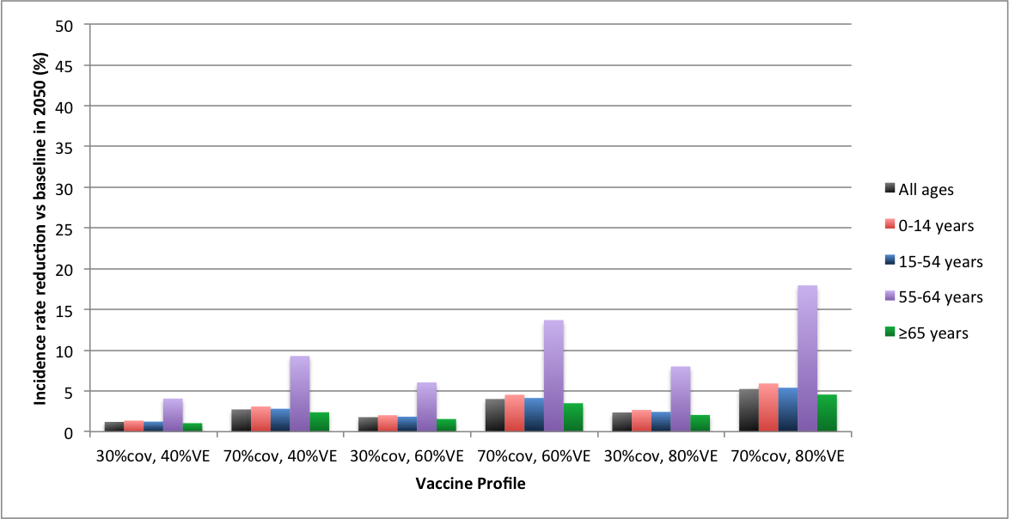

Figure 1: Incidence rate reduction by pre-infection vaccine profiles in 2050 compared to baseline, all ages and by age.

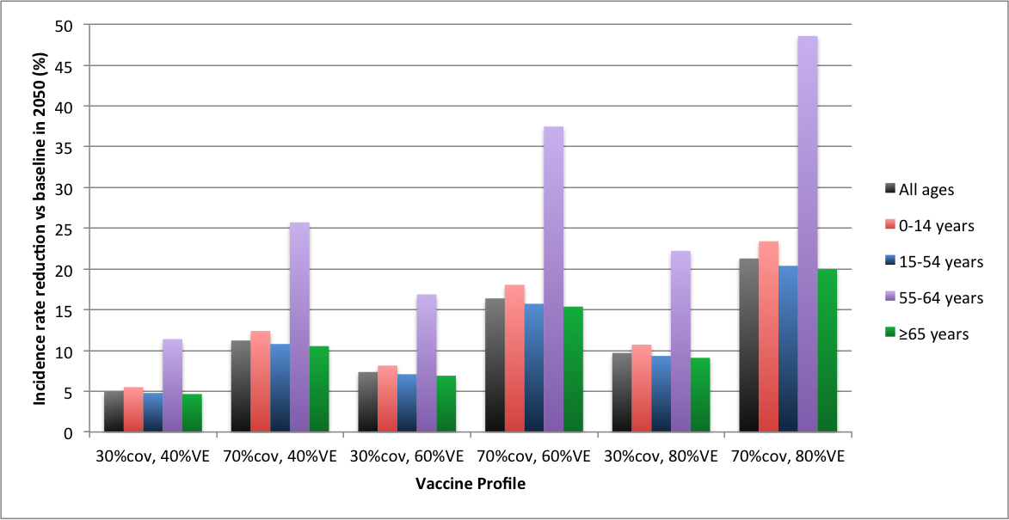

Figure 2: Incidence rate reduction by post-infection vaccine profiles in 2050 compared to baseline, all ages and by age.

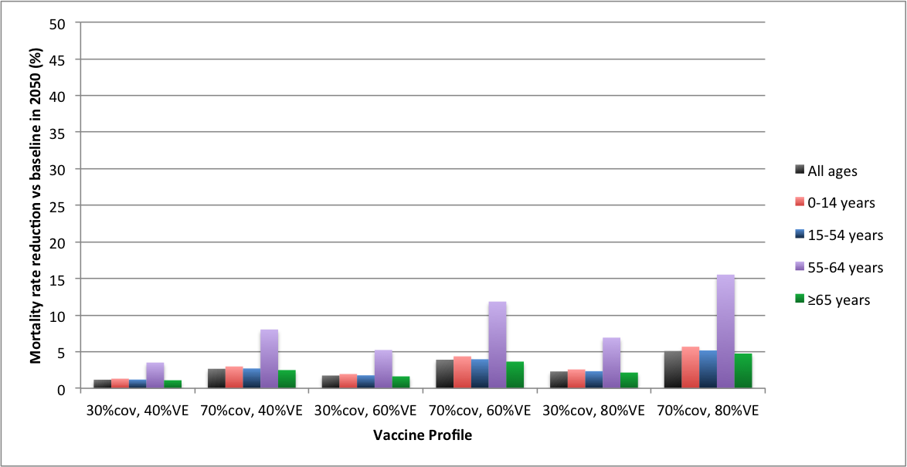

Figure 3: Mortality rate reduction by pre-infection vaccine profiles in 2050 compared to baseline, all ages and by age.

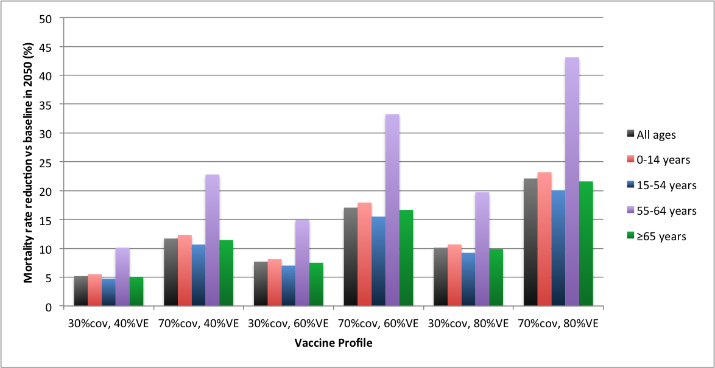

Figure 4: Mortality rate reduction by post-infection vaccine profiles in 2050 compared to baseline, all ages and by age.

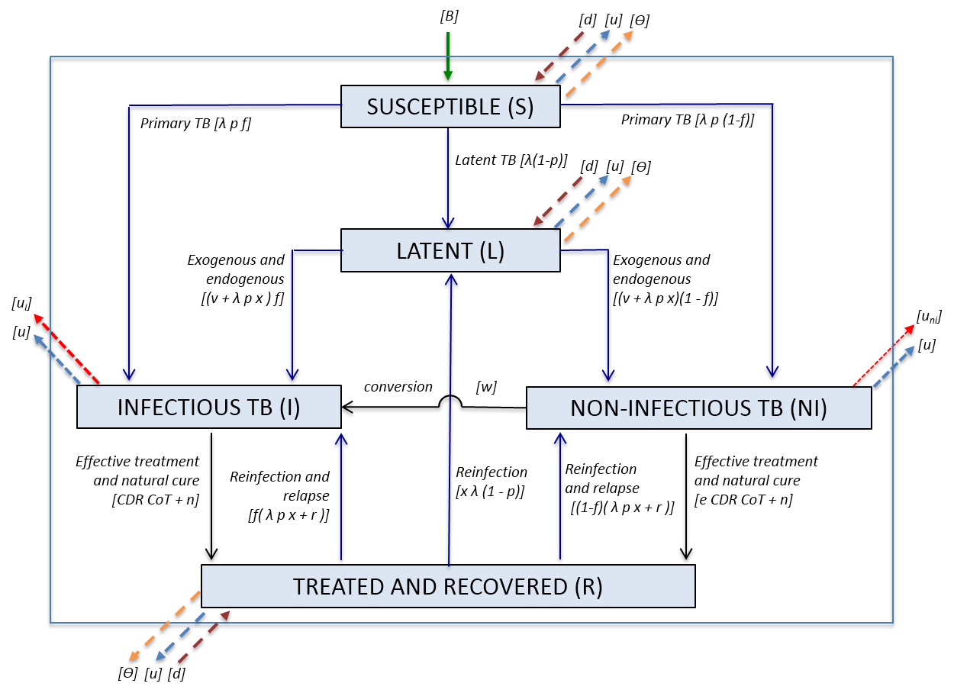

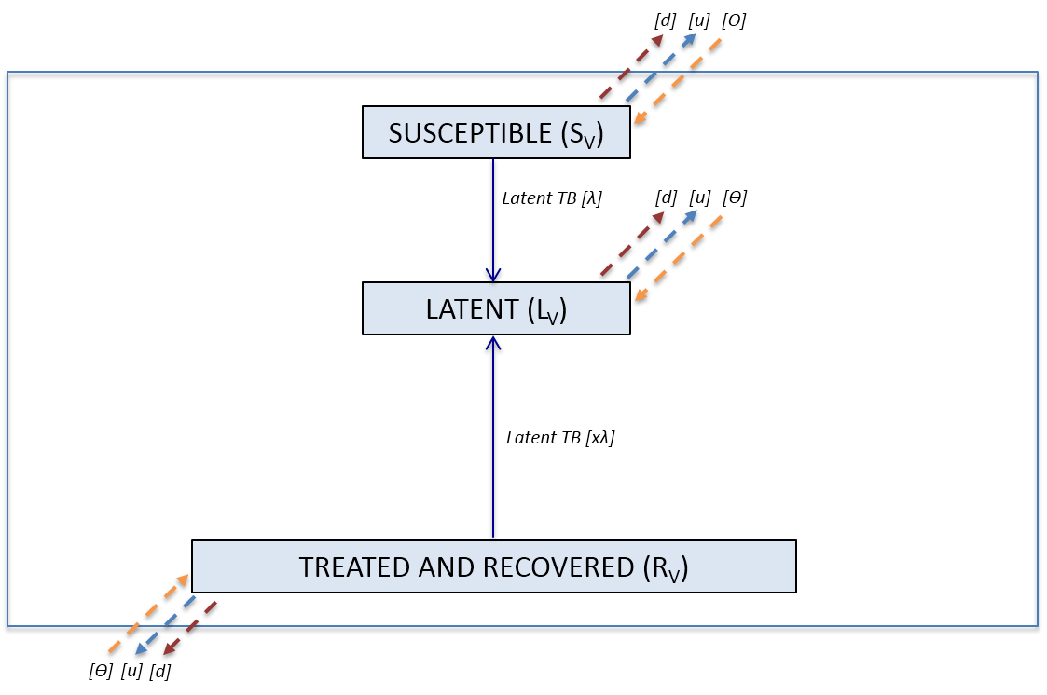

Figure 11: Model structure based on Knight et al. (in press) [knight ref]

***Appendices***

##### Appendix A. Model Structure

The model is based on an existing mathematical model of global TB vaccine impact,6 adapted to capture the demographics and epidemiology in China. The model is an age-structured compartmental transmission model described by a series of difference equations (figure 1). The model is programmed in R.

The model is age structured by single years to provide granularity for vaccination strategies, duration of protection and flexibility in age-applicability of natural history parameters.

The natural history of tuberculosis is described by five epidemiological states: susceptible, latently infected, infectious active disease, non-infectious active disease, and recovered (Figure 7 top). The susceptible population is defined as those never infected with Mycobacterium tuberculosis, latent as the population remaining infected without developing clinical symptoms, infectious disease as those with smear-positive pulmonary TB, non-infectious as patients with smear-negative pulmonary TB or extra-pulmonary TB, and recovered as those who have either received treatment or naturally recovered from active disease.

Births enter the system as susceptibles at rate B[k]. Susceptible individuals are infected at rate λ, of which a proportion (*p*) progress directly to active disease and the remainder (1-*p*) enter the latent state. Latently infected individuals can develop active disease through reinfection (λ*p*) or reactivation of disease (*v*). Latently infected individuals experience a reduced susceptibility to re-infection by factor *x*. Of those latents and susceptibles progressing to active disease, a proportion (*f*) develop infectious TB (smear positive), and the remainder (1*-f*) develop non-infectious TB (smear negative or extra-pulmonary TB). Individuals with non-infectious TB progress to infectious disease at rate *w*.

Individuals can leave the active disease state either by natural cure (*n*) or detection and effective treatment (CDCoT), the former of which is scaled down by factor e for non-infectious disease, as these cases are less likely to be detected. Recovered individuals can relapse to active disease at rate r or be reinfected and enter the latent or active disease states as described above.

Individuals can leave any state due to natural death at rate *u*, and infectious or non-infectious disease states due to TB-related mortality at rates *ui* and *uni,* respectively.

Vaccination is incorporated into the model through a distinct vaccinated stratum, consisting of susceptible, latent and recovered states (Figure 1, bottom). Active disease states are excluded from the vaccine stratum as therapeutic vaccination is not considered, and the vaccine mechanisms modelled stop progression to active disease. Upon vaccination, individuals move from the susceptible, latent and recovered unvaccinated population to the vaccinated population at rate , respectively. Individuals leave the vaccine stratum either through background mortality (*u*) or reaching the end of the duration of protection and thus returning to the unvaccinated stratum at rate *d*.

**Appendix B. Model equations**

The equations for the five *Mtb* sub-populations in year *k*, time step *i* and age *j* are shown below. The size of the time step is *dt*. Thus is the initial time and here . The method of Schenzle (1984) is used to model ageing – at the end of each year all members of the population age by one year. New-borns (births) enter the population as Susceptibles at the start of each year.

The first set of equations is valid for all time steps *except* that at the start of the year. Equations for the first time step of the year are given in the Aging section below.

For the baseline scenario of no vaccination, and d will be set to zero.

*Transmission*

where and *nygrp* is the number of contact age groups, m is the age group of the individual exposed to infection (including age *j*), *y* is age group of contacts, is number of respiratory contacts of age group *m* with contacts of age group y, is the calibration factor for model fitting, is the probability of transmission per respiratory contact between an Infectious and Susceptible, and *jmin and jmax* are the lower and upper bounds of age classes within a contact age group (*y*).

**For time steps not the start of the year**

**Unvaccinated**

*Susceptibles*

*Latent*

*New infectious active TB cases*

*New non-infectious active TB cases*

*Infectious active TB cases*

*Non-infectious active TB cases*

*Recovered*

where *CDR[k]* is the case detection rate and *CoT[k]* the proportion successfully treated in year *k*.

**Vaccinated**

Vaccination only occurs at first time step of year, so in the middle of the year the only changes to occur are moving between groups in the same stratum.

For vaccines only efficacious when delivered pre-infection, will be zero, therefore will remain at zero throughout the model.

*Susceptibles*

*Latent*

*Recovered*

**Aging and Vaccine Delivery/Waning (At first time point of the year)**

If *i* is the **first time point of a year *k*,** then the updated values are functions of those aged one year younger in the previous time step in the method of Schenzle (Schenzle, 1984).

The key equations at the start of the year are those for Susceptibles as the number of births, *B[k],* in year *k* are all assumed susceptible. Vaccination and end of duration of protection is assumed to occur in the first time step of a given year. Here is the risk of ending vaccine protection at time step *i* and age *j*. The vaccinated terms are not multiplied by *dt* as they only occur at set time steps in the year.

**Unvaccinated**

*Susceptibles*

*If j=1:*

*If j≠1:*

*Latent*

*New infectious active TB cases*

*New non-infectious active TB cases*

*Infectious active TB cases*

*Non-infectious active TB cases*

*Recovered*

**Vaccinated**

Mechanism of action can be altered by changing values of . Pre-infection vaccine will only contain non-zero values for Whereas the post-infection vaccine will contain non-zero values for , and for will depend on whether vaccine provides no protection, reduced protection, or full protection to susceptibles.

*TB Susceptibles*

*Latent*

*Recovered*

The pre-infection vaccine will be modelled setting and to zero so that no vaccination of recovered can occur, and vaccinated latents can only arise from infection of vaccinated susceptibles.

The post-infection vaccine will be modelled as a ‘mixed effects’ vaccine, meaning it will be equally effective in all model classes without active TB (i.e. susceptible, latent and recovered). In the future, reducing VE in the susceptible class ( may be explored to reflect the possibility of decreased vaccine efficacy in populations not primed by previous infection.

##### Appendix C. Model Parameters and Data Sources

Justification of selection and sources for natural history and interventional parameters are described below.

#### Natural History Parameters

The host immune response is central in the containment of *Mtb* infection and in disease progression, therefore immune immaturity in children and immunosenescence in the elderly is believed to impact the course of infection and disease. Additional factors such as higher rates of comorbidities, increased frequency of adverse drug reactions, impaired microbial clearance mechanisms, and increased frequency of atypical disease manifestations leading to diagnostic and treatment delays, may worsen TB prognoses in the elderly.9 Social factors such as institutionalisation (e.g. hospitals, elderly care homes) and social contact patterns may also play a role in the increased rates of TB observed in the elderly age group.9 Given these biological and social differences it is important to consider potential age specific model parameters.

*1a. Biological Parameters*

Due to confidence in the epidemiological and/or biological basis for age-based differences, the following biological parameters were considered to vary by age: proportion progressing directly to active disease (*p[j])*, proportion developing infectious disease (*f[j])* and risk of reactivation of latent infection or relapse of recovered disease (*v* and *r*), and risk of natural cure from active disease (*n*). These were parameterised separately for children (0-14 years), adolescents and adults (15-64 years) and the elderly (≥65 years). Higher rates of disease and mortality in the elderly are due to high prevalence of infection and immune senescence. Due to the impact of immunosenescence in the elderly, where elderly data were unavailable, a range for the biological parameters with the upper limit as the mid-point of the parameter range for HIV-positives was employed for model fitting (see table XXX).

Parameters considered invariant by age or with insufficient data demonstrating age variability will be taken as single values based on estimates from the literature, and are in line with values applied in Knight et al. and historical literature.6,4 These include probability of transmission per infectious contact (*z*) and protection from active disease due to latent infection (*x*).

The model has been adapted to allow TB mortality rate to vary by age, however in this preliminary hand-fitted model the age-wise scaling factors were held at 1.

Parameter tables have been adapted from Knight et al.[knight ref]

#### Table C1 - Natural history

|  |  |  |  |  |  |  |
| --- | --- | --- | --- | --- | --- | --- |
|  | **Symbol** | **Description** | **Notes** | **Proposed value (ranges for sensitivity)** | **References** | **Model Values** |
| **Births** | *B[k]* | Number of births in year *k* |  | / | UN Population Division (2010 revision 2012 | / |
| **Transmission** | *λ[i,j]* | *Mtb* transmission risk (force of infection) in time step *i* for age *j* | Calculated per time step |  | | / |
| *ηcal* | Scaling and calibration factor number of respiratory contacts |  | Scales respiratory contacts to annual number of contacts and calibrates to TB incidence | | 7.5 |
| *η[m,y]* | Daily number of respiratory contacts by age group *m* and contacts in age group *y* | Varies by age group | Calibrated by *ηcal* to match TB incidence  Initial values and mixing patterns taken from Read *et al* 2014. | | / |
| *z* | Probability of transmission per respiratory contact between an Infectious and Susceptible |  | 0.1 | Dye et al 2008 | 0.1 |
| **Progression** | *p[j]* | Proportion of (re-) infected Susceptible, Latents or Recovereds which develop active TB | Varies by age | *p[ j < 15]* = 0.02 (0.01-0.06);  *p[ j* ≥ *15, <65]* = 0.15 (0.08 – 0.25)  *p[ j* ≥ *65]* = 0.08-0.5 | Elderly range based on adult and HIV-positive ranges  Abu Raddad et al 2009  Dye et al 2008 | *p[ j < 15]* = 0.028  *p[ j* ≥*15, <65]* = 0.147  *p[ j* ≥*65]* = 0.4 |
| *x* | Protection from developing active TB due to being latently infected or recovered from infection | *(1-x)* is the value for the level of protection afforded (e.g. here 65% in HIV negatives) | *x* = 0.35 (0.25 – 0.45) | Abu Raddad et al 2009  Dye et al 2008  Gomes et al 2007 | 0.30 |
| *v[j]* | Risk of reactivation among latent infections |  | *v* *[ j<65]* = 1.13 x 10-4 (1-3 x 10-4)  *v[ j* ≥ *65]* = 1 x 10-4 - 0.04 | Dye et al 1998  Gomes et al 2007  Elderly upper bound higher than adults, but lower than HIV-positives | *v[ j <65]* = 0.00014  *v[ j* ≥*65]* = 0.002 |
| **Infectious TB** | *f[j]* | Proportion of new active cases which directly become infectious | Varies by age. | *f[j < 15] = 0.1 (0-0.15);*  *f[j* ≥ *15, <65] = 0.5 (0.25-0.75) ;*  *f[ j* ≥ *65]* = 0.19-0.75 | Abu Raddad et al 2009  Dye et al 2008  Elderly range based on adult and HIV-positive ranges. | *f[j<15]= 0.06*  *f[j* ≥ *15, <65] = 0.55*  *f[ j* ≥ *65]* = 0.5 |
| *w* | Risk of converting from non-infectious to infectious |  | 0.015 (0.007 – 0.02) | Dye et al 1998  Ferebee | 0.0089 |
| **Mortality** | *u[j]* | Background death risk at age *j* | *Varies by age* | *u[j] = 1/LE* | Taken from UN Population Division data (2012 revision) | / |
| *rmort\** | Calibration factor | *Varies by age* | Calibrated to match population size by age group in 2010 and 2050.  Range sampled: (-1,1)  If (*rmort* < 0 ): *u[j]*=(1+*rmort*) *u[j]*  If (*rmort* ≥0): *u[j]*=(1-*u[j]*)rmort + *u[j]* | | -0.6 |
| *ui*; | Death risk for infectious untreated TB | *Varies by age* | Calibrated to match TB mortality by rmortTB | Tiemersma et al 2011 | / |
| *uni* | Death risk for non-infectious untreated TB | *Varies by age* | Calibrated to match TB mortality by rmortTB | Tiemersma et al 2011 | / |
|  | *rmortTB\** | Calibration factor | / | Calibrated to match TB mortality.  Range sampled: (-1,1)  If (*rmortTB* < 0 ): *u­i*=(1+*rmortTB*)*ui* , *u­ni*=(1+*rmortTB*)*uni*  If (*rmortTB* ≥0): *u­i*=(1-*ui*)*rmortTB* + *ui* , *u­ni*=(1-*uni*)*rmortTB* + *uni* | | -0.75 |
| **Natural cure and relapse** | *n* | Annual risk of natural cure for TB cases |  | n = 0.1 (0.15 – 0.25) | Abu Raddad et al 2009  Dye et al 2008 | 0.24 |
| *r* | Annual risk of relapse from recovered to active TB |  | *r[j <65] = 0.005-0.015*  *r[ j* ≥ *65]* = 0.005-0.2 | Gomes et al 2004  Elderly upper bound equal to HIV-positives lower bound | *r[j<65] = 0.0074*  *r[ j* ≥ *65]* =0.02 |

#### Table C2 - Control measures

|  |  |  |  |  |  |  |
| --- | --- | --- | --- | --- | --- | --- |
| **Treatment** | *CDR[k]* | Case Detection Ratio (Proportion of new active TB cases detected and started on treatment) in year *k* | Varies over time. | 2012 baseline: 89%  Scale up based upon data until 2012, then constant CDR from 2012 onwards | WHO China country Profile 2012 | / |
| *CDRscale\** | Calibration factor for CDR (and CoT given CDR*CoT) | Allowed to vary separately by elderly vs non-elderly | Calibrated to match TB prevalence, mortality and incidence. Range sampled: (-0.5, 2)  *CDR[k]=CDRscale*CDR[k]* | | *CDRscale[j<65] = 0.52*  *CDRscale[j*≥*65]* = -0.05 |
| *CoT[k]* | Treatment success proportion (cured or complete treatment) in year *k* | Varies over time. | 2011 baseline: 95%  Scale up based upon data until 2012, then constant CDR from 2011 onwards | WHO China country Profile 2012 | / |
| *e* | Relative case detection rate of non-infectious cases |  | 0.6 (0.4 – 0.8) | Assumed | 0.57 |

#### Table C3 - Vaccine parameters

|  |  |  |  |  |  |  |
| --- | --- | --- | --- | --- | --- | --- |
| **Vaccine** | *c[k,j];* | Coverage of vaccine to those aged *j* at year *k* |  | Elderly: Steady state at 55yrs 30% and 70%, plus 3 year catch up campaign for 55-64yrs with coverage distributed over period of campaign | Assumed. Lower limit ensures encompasses coverage in elderly for flu vaccines | 30% and 70% |
| *aI* | Efficacy in preventing active disease | Vaccine dependent. | 40%, 60%, 80% | Assumed | 40%, 60%, 80% |
| *θ[k,j];* | Proportion of Susceptibles, Latents and Recovereds aged *j* that move to the vaccine strata in year *k* | Product of coverage and vaccine efficacy. | *θ[k,j] = c[k,j] × aI* | / | / |
| *D* | Duration of vaccine efficacy | Vaccine dependent. | 5% waning per year (departure from vaccinated class), with 20years maximum duration of protection. | Assumed | 20yrs, 5% waning per year |

*1b. Social Parameters*

Previous TB vaccine models have assumed random mixing patterns.6,4,5,10 However, homogenous mixing does not appropriately represent the reality of age-biases in contact patterns, which are important in this model since it will investigate age-targeted vaccination. A study in China by Read *et al.* estimated the total and average daily number and duration of contacts by age strata (0-5, 6-19, 20-64 and ≥ 65years) from contact diaries, in a study enrolling 1821 participants from southern China.8 Contacts were defined as face-to-face conversation or skin-on-skin touch, so are broadly representative of the type of contact relevant to *Mtb* transmission.8 The study showed that the number of contacts was lowest in the elderly population and that the duration of contacts declined with increasing age (Figure B1, Left). 8 The clear age assortativity and total contact differences observed in the Read study could have an important impact on the transmission parameters in an age-structured model such as this. Therefore, these social mixing patterns will be incorporated in the model.

The heterogeneous mixing pattern is incorporated in the model in the term . This is a matrix of the average number of contacts per person per day between an individual in the participant group (m) and individuals in a contact age group (y) (cym)(figure B1). This is multiplied by a scaling factor to calibrate the total number of contacts to the incidence rate data. The matrix reporting average number of contacts between age groups in the Read paper is asymmetric due to reporting or participation biases (Figure B1, left),8 but in reality the total number of contacts should be symmetric as total number of contacts of group m meeting with group y is the same total number as y meeting with m. A symmetric contact matrix was calculated by estimating the total number of contacts from and all subjects in participant age group m with contact age group y, and for the age groups reversed, and taking an average of the two. This is then converted back to a contact rate by dividing the values by the size of the participant age group (Figure B1, right), calculating cym by: where is average number of contacts of participants in group m with people in group y, is average number of contacts of participants in group y with people in group m, and and are the number of participants in age group m and y, respectively.11

In the model, this contact matrix is then multiplied by the probability of transmission occurring upon a respiratory contact between an infectious and susceptible (z) and by the proportion of the contact population that are infected . These are summed over the contact age groups to give *Mtb* transmission risk (force of infection) in time step i for age j (*λ[i,j]*)

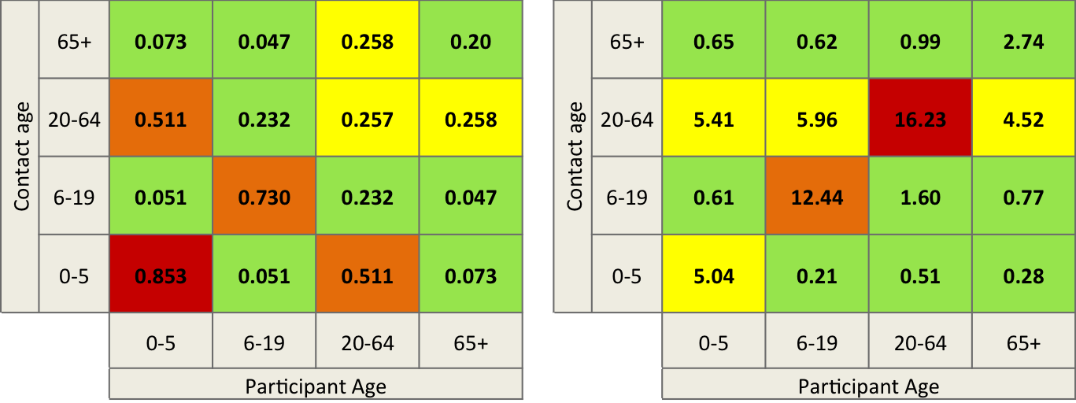

Figure C12: Average number of reported contacts per day (left, Read *et al.* 2014.) and average number of contacts per person in the participant age group per day following matrix averaging to ensure symmetric total numbers of contacts (right)

#### Existing control measures

Outcomes will be calculated assuming BCG coverage at current levels. Uncertainty in case detection estimates is well documented, therefore a logistic curve based on WHO estimates of CDR between 1990 and 2010 with the steepest gradient aligned with the inflexion point in the data was used. CDR and treatment success were held constant at the 1990 and 1994 rate pre-1990 and -1994, respectively, and at the 2012 value post-2012. WHO reported treatment success rates were employed between 1994 and 2012.

#### Vaccine Parameters

Vaccine introduction is implemented in 2025, and vaccine profiles differed by mechanism of action, duration of protection, and vaccine efficacy. Six vaccine profiles are being investigated, including two mechanisms of action (protection if given pre-infection or post-infection) and vaccine efficacy (VE) of 40%, 60% or 80%. The target population is ‘elderly’, therefore vaccination was delivered to 55 year olds, with the intention of protecting the population before they enter the ‘elderly’ period (65 years and above). The model assesses 20 years duration of protection with waning by 5% per year during the ‘protected’ period due to immunosenescence. Vaccination is modelled as ‘take’ and duration of protection exact. The model explores vaccination coverage of 30% and 70% of the target population. A catch-up campaign of 56-64year olds starting in 2025 extending over a period of 3 years was employed, with target coverage divided equally across the 3 years of the campaign.

*3a. Vaccine mechanism*

The impact of pre- and post-infection prophylactic vaccines will be explored. The pre-infection vaccine is assumed to prevent development of active disease only in never-infected individuals (), whereas the post-infection (or mixed effects) vaccine is assumed to prevent development of active disease when given to populations never-infected (susceptibles), latently infected, or recovered from active disease (). Neither vaccine profile is expected to protect from infection, therefore once vaccinated it is possible to become infected and move to the vaccinated latent class.

*3b. Vaccine Efficacy*

TB vaccine models in the literature have mostly explored a VE range of 20-90%.4,13,6,14,15,16,17,18,16,19 Given the challenges to develop an effective TB vaccine, the upper bound of efficacy considered in this model is reduced to 80%. It is hoped that the model can explore whether vaccines with lower vaccine efficacy could have sufficient public health impact to be worth implementing, but detecting a VE of as low as 20% would necessitate unfeasibly large clinical trials and is not expected to have big enough public health impact, therefore a lower bound of 40% VE was selected.

*3c. Vaccine Coverage*

The model will explore vaccination coverage of 30% and 70% of the target population. Instant scale-up of vaccination will be assumed, with the exception of the elderly catch-up campaign, which will evenly distribute the coverage over the 3-year campaign (e.g. 30% coverage assumes 10% per year for 3 years).

Influenza vaccination rates were considered a good proxy for expected elderly TB coverage as influenza vaccination is provided free of charge to citizens ≥60years in government-run hospitals. Studies of self-reported coverage in the elderly indicate vaccine coverage of 36-49% in the 2008-2011 period.21,22 The upper bound explored in the model is informed by a qualitative study of acceptance of hypothetical adult hepatitis B vaccination policies, in which unvaccinated respondents indicated a 55-72% acceptance rate if the vaccine were offered free of charge with 0-100 Yuan compensation towards indirect costs.25

*3d. Vaccine Duration and Waning of Protection*

Vaccination is modelled as ‘take’. Vaccine protection wanes due to immunosenescence at 5% per year, with those losing their protection returned to the unvaccinated class. Duration of protection (20 years) is exact, meaning that any remaining in the vaccinated class at the end of the duration of protection are returned to the unvaccinated class.

The target population is ‘elderly’, for which populations will be vaccinated pre-65years to provide protection into the elderly ages. Elderly vaccination will involve continuous vaccination of adults aged 55 years old from 2025, plus a 3-year catch up campaign of 56-65 year olds during 2025-2027. It is expected that adults 65 years and above would not receive the vaccine due to safety concerns and immune senescence, therefore continuous vaccination is anticipated to be delivered at 55 years old to ensure a robust immune response ahead of immunosenescence.

#### Calibration targets

The model was calibrated by hand to China-specific estimates of age-stratified TB incidence and mortality rates in 2010, age-stratified pulmonary TB prevalence rates in 2000 and 2010, and the estimated population size stratified by age for 2010 and 2050. Fitting was conducted in the following order of priority: prevalence rates, followed by mortality rates and finally incidence rates. Justification for such prioritisation is described in section XXX. Calibration target values are summarised in Table B4.

Four of the parameters are set at a single value and the model value determined by multiplying that parameter by a randomly sampled scaling factor. These scaling factors allow for refinement of model fit and include: total number of contacts (neta) used to calculate transmission rate, case detection rate and treatment success (CDRscale), background mortality (rmort), and TB-specific mortality (rmortTB).

To ensure a good age-structured demographic model fit, mortality and birth rates were adjusted over time. Birth rate is held constant at the UNPD-estimated 1950 rate until 1990, where it drops to the 2010 rate. This birth rate decline reflects the introduction of the one-child policy in 1979, with a built in delay since the response to the policy is unlikely to have been immediate. From 2010 onwards the birth rate follows reported data.

Mortality by year of age and by calendar year was calculated using life expectancy (LE) at exact age to calculate annual risk of death (1/LE) [UNDP ref]. Mortality rate was held constant at the 1950 rate pre-2000, then at the 2000 rate for 2000-2010, then permitted to follow the data from 2010 onwards.

Modelling fitting using the Approximate Bayesian Computation algorithm as described in Marjoram et al. and Knight et al. will be conducted, however this will be part of the further research following these preliminary outcomes.

Table C4: Calibration targets for China model

|  |  |  |  |  |  |
| --- | --- | --- | --- | --- | --- |
| **Calibration Factor** | **Year** | **Age (years)** | **Estimate** | **Lower bound** | **Upper bound** |
| Population size (thousands)3 | 2010 | 0-14 | 246707 | n/a | n/a |
| 15-54 | 863710 | n/a | n/a |
| 55-64 | 135859 | n/a | n/a |
| 65+ | 113546 | n/a | n/a |
| 2050 | 0-14 | 204187 | 124968 | 300552 |
| 15-54 | 623982 | 527054 | 722200 |
| 55-64 | 225492 | 202943 | 2480414 |
| 65+ | 331315 | 298184 | 364447 |
| All TB incidence rate[1]  (/100,000/yr)2 | 2010 | 0-14 | 3.02 | 2.65 | 3.41 |
| 15-54 | 74.56 | 65.43 | 84.37 |
| 55-64 | 120.54 | 105.78 | 136.40 |
| 65+ | 165.63 | 145.35 | 187.43 |
| TB Mortality Rate  (/100,000/yr)7 | 2010 | 0-14 | 0.29 | 0.27 | 0.32 |
| 15-59 | 1.91 | 1.72 | 2.10 |
| 60+ | 15.69 | 14.12 | 17.26 |
| Pulmonary TB prevalence rate  (/100,000/yr)1 | 2000 | 15-29 | 92 | 72 | 116 |
| 30-44 | 119 | 96 | 146 |
| 45-59 | 213 | 174 | 260 |
| 60+ | 596 | 510 | 698 |
| 2010 | 15-29 | 59 | 40 | 86 |
| 30-44 | 73 | 54 | 99 |
| 45-59 | 133 | 106 | 168 |
| 60+ | 346 | 294 | 407 |

**REFERENCES**

1. Wang L, Zhang H, Ruan Y, Chin DP, Xia Y, Cheng S, et al. Tuberculosis prevalence in China, 1990-2010; a longitudinal analysis of national survey data. The Lancet. 2014

2. WHO. Global Tuberculosis Report 2013. 2013

3. World Population Prospects: The 2012 Revision, Highlights and Advance Tables. ESA/P/WP.228: United Nations, Department of Economic and Social Affairs, Population Division (2013).

4. Abu-Raddad LJ, Sabatelli L, Achterberg JT, Sugimoto JD, Longini IM, Dye C, et al. Epidemiological benefits of more-effective tuberculosis vaccines, drugs, and diagnostics. Proceedings of the National Academy of Sciences. 2009 August 18, 2009;106(33):13980-5

5. Dye C, Glaziou P, Floyd K, Raviglione M. Prospects for tuberculosis elimination. Annual review of public health. 2013;34:271-86

6. Knight GMG, U.K.; Sumner, T.; Laurence, Y.; Gheorghe, A,; Vassal, A.; Glaziou, P.; White, R.G. Impact and cost-effectiveness of new tuberculosis vaccines in low- and middle-income countries. Submitted to Journal

7. Zhang H, Huang F, Chen W, Du X, Zhou MG, Hu J, et al. Estimates of tuberculosis mortality rates in China using the disease surveillance point system, 2004-2010. Biomedical and environmental sciences : BES. 2012 Aug;25(4):483-8

8. Read JM, Lessler J, Riley S, Wang S, Tan LJ, Kwok KO, et al. Social mixing patterns in rural and urban areas of southern China. Proceedings of the Royal Society B: Biological Sciences. 2014 June 22, 2014;281(1785)

9. Rajagopalan S. Tuberculosis and aging: a global health problem. Clinical infectious diseases : an official publication of the Infectious Diseases Society of America. 2001 Oct 1;33(7):1034-9

10. Dye C, Williams BG. Eliminating human tuberculosis in the twenty-first century. Journal of the Royal Society, Interface / the Royal Society. 2008 Jun 6;5(23):653-62

11. Baguelin M, Flasche S, Camacho A, Demiris N, Miller E, Edmunds WJ. Assessing Optimal Target Populations for Influenza Vaccination Programmes: An Evidence Synthesis and Modelling Study. PLoS medicine. 2013;10(10):e1001527

12. WHO. Countdown to 2015, Global TB Report 2013 Supplement. 2013

13. Ditkowsky JB, Schwartzman K. Potential Cost-Effectiveness of a New Infant Tuberculosis Vaccine in South Africa - Implications for Clinical Trials: A Decision Analysis. PloS one. 2014;9(1):e83526

14. Rahman M, Sekimoto M, Takamatsu I, Hira K, Shimbo T, Toyoshima K, et al. Economic evaluation of universal BCG vaccination of Japanese infants. International journal of epidemiology. 2001 Apr;30(2):380-5

15. Young D, Dye C. The development and impact of tuberculosis vaccines. Cell. 2006 Feb 24;124(4):683-7

16. Tseng CL, Oxlade O, Menzies D, Aspler A, Schwartzman K. Cost-effectiveness of novel vaccines for tuberculosis control: a decision analysis study. BMC Public Health. 2011;11:55

17. Gomes MG, Franco AO, Gomes MC, Medley GF. The reinfection threshold promotes variability in tuberculosis epidemiology and vaccine efficacy. Proceedings Biological sciences / The Royal Society. 2004 Mar 22;271(1539):617-23

18. Murray CJ, Salomon JA. Modeling the impact of global tuberculosis control strategies. Proceedings of the National Academy of Sciences of the United States of America. 1998 Nov 10;95(23):13881-6

19. Ziv E, Daley CL, Blower S. Potential public health impact of new tuberculosis vaccines. Emerging infectious diseases. 2004 Sep;10(9):1529-35

20. World Bank. Data bank, school enrolment, secondary [cited 2014 17th June]. Available from: <http://data.worldbank.org/indicator/SE.SEC.ENRR>.

21. Zheng Y, Yang P, Wu S, Ma C, Seale H, MacIntyre CR, et al. A cross-sectional study of factors associated with uptake of vaccination against influenza among older residents in the postpandemic season in Beijing, China. BMJ Open. 2013 November 1, 2013;3(11)

22. Wu S, Yang P, Li H, Ma C, Zhang Y, Wang Q. Influenza vaccination coverage rates among adults before and after the 2009 influenza pandemic and the reasons for non-vaccination in Beijing, China: a cross-sectional study. BMC Public Health. 2013;13:636

23. Blank PR, Bonnelye G, Ducastel A, Szucs TD. Attitudes of the general public and general practitioners in five countries towards pandemic and seasonal influenza vaccines during season 2009/2010. PloS one. 2012;7(10):e45450

24. Zhou L, Su Q, Xu Z, Feng A, Jin H, Wang S, et al. Seasonal influenza vaccination coverage rate of target groups in selected cities and provinces in China by season (2009/10 to 2011/12). PloS one. 2013;8(9):e73724

25. Zhu D, Wang J, Wangen KR. Hepatitis B vaccination coverage rates among adults in rural China: Are economic barriers relevant? Vaccine. (0)

26. Marjoram P, Molitor J, Plagnol V, Tavare S. Markov chain Monte Carlo without likelihoods. Proceedings of the National Academy of Sciences of the United States of America. 2003 Dec 23;100(26):15324-8

1. TB incidence estimated by applying WHO-reported Chinese CNR to the age-stratified all TB notifications, and converted to rates by dividing by 2010 population estimates. Bounds informed by CNR 95% confidence intervals.